វិទ្យាស្ថានបច្ចេកវិទ្យាកម្ពុជា

Institute of Technology of Cambodia

Department of Information and Communication



Subject: Internet Programming

Professor: HOK TIN

Assignment: TP2 (CSS, Canvas, CRUD)

Name: LAY Vicha

ID: e20190494

Group: I4-GIC-B

2022-2023

Contents

1. EX1-CSS with Tailwind 1

2. EX2-Runaway button with TweenJS 2

3. EX3-Canvas draw an image 3

4. EX4-Canvas live video 4

5. EX5- Canvas and crop them with OpenCV library 5

6. EX6-CRUD 6

# EX1-CSS with Tailwind



# EX2-Runaway button with TweenJS



# EX3-Canvas draw an image

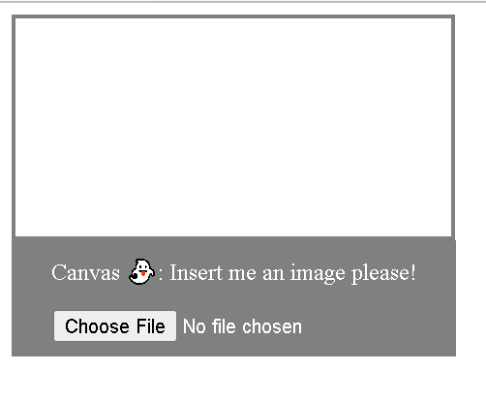

# EX4-Canvas live video

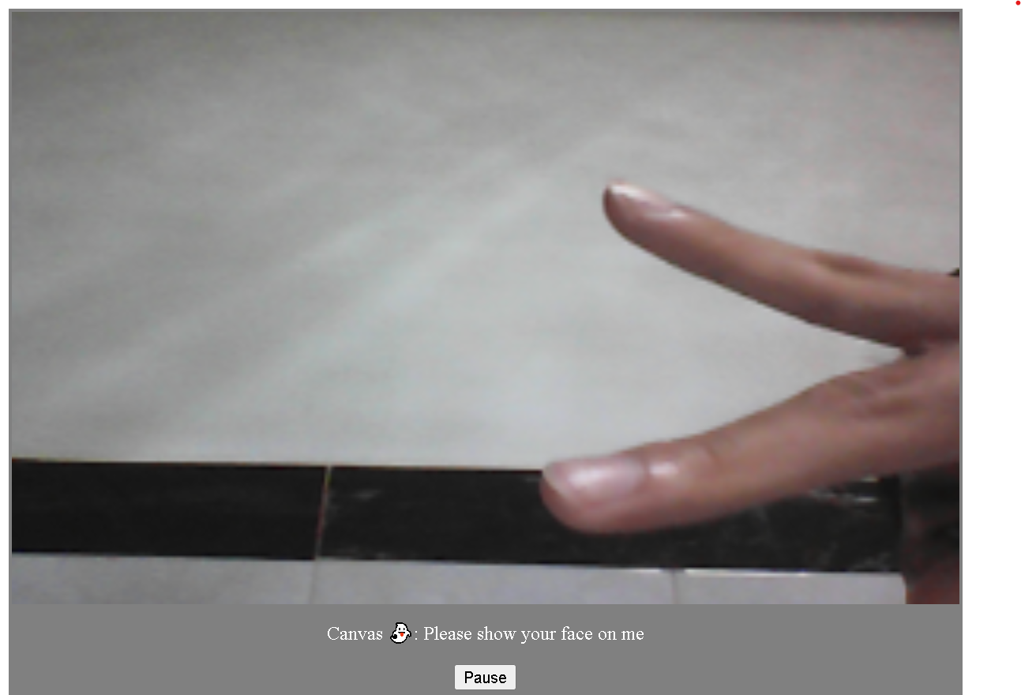

# EX5- Canvas and crop them with OpenCV library

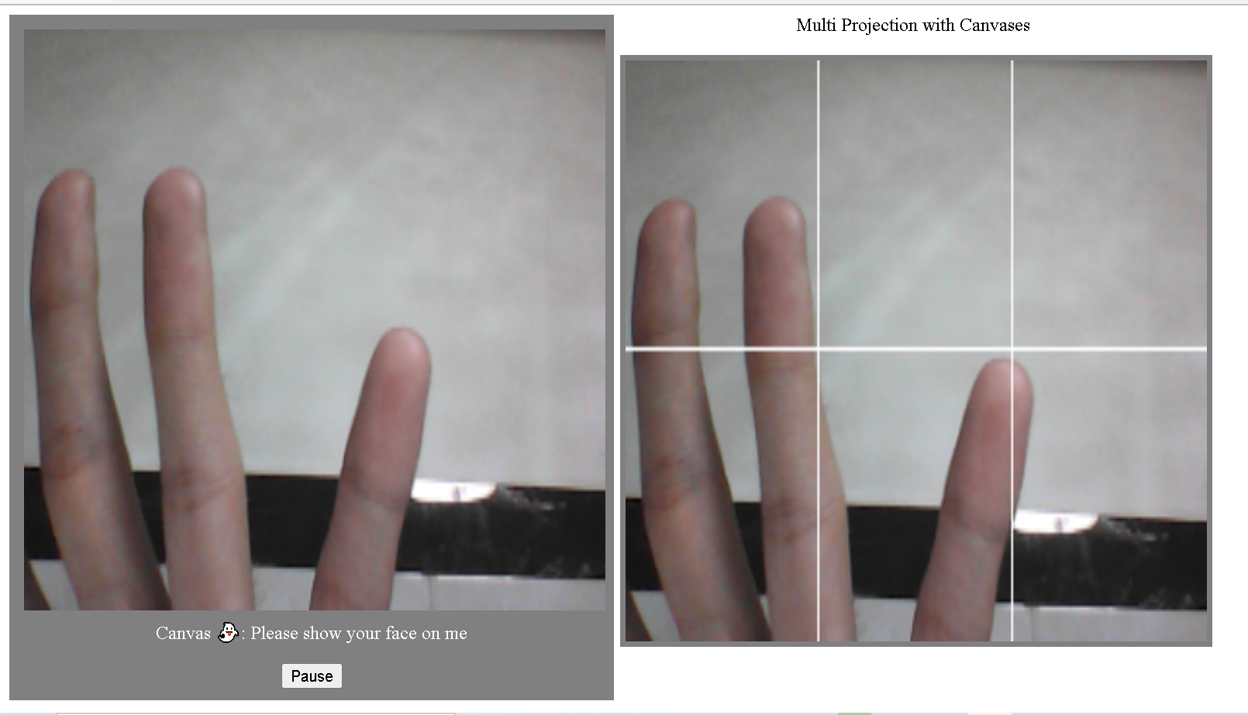

# EX6-CRUD

